

TITLE
Subtitle
Diogo Domingues Godinho

Master Thesis
presented as partial requirement for obtaining a Master’s Degree in Information Management

NOVA Information Management School
Instituto Superior de Estatística e Gestão de Informação
Universidade Nova de Lisboa

NOVA Information Management School
Instituto Superior de Estatística e Gestão de Informação
Universidade Nova de Lisboa

TITLE
Subtitle

by
Diogo Domingues Godinho

Master Thesis presented as partial requirement for obtaining the Master’s degree in Information Management, with a specialization in ………

Supervised by
Supervisor’s name, academic title (PhD; MSc…), Academic institution or School affiliation of the supervisor
EXAMPLE: Miguel de Castro Neto, PhD, NOVA Information Management School

Month, Year

Statement of Integrity
I hereby declare having conducted this academic work with integrity. I confirm that I have not used plagiarism, any form of undue use of information or falsification of results along the process leading to its elaboration. I further declare that I have fully acknowledged the Rules of Conduct and Code of Honor from the NOVA Information Management School.
[place, date]
Just type your name, not your signature

Dedication (OPTIONAL)

Just if you want to dedicate your work to someone dear to you or to someone that inspired you in your life. Here is not the place for acknowledge, it is a distinct honour to someone, although it is optional.

Acknowledgements (OPTIONAL)

This is an optional page, however it is always very important to acknowledge those who made this possible, like family, friends, colleagues, professors, staff, University, and those who anonymously participated in the data collection phase, for example.

Abstract
This work presents an innovative approach to injury forecasting, performance projection, and athlete evaluation in the NFL by integrating Agentic Artificial Intelligence, Generative Artificial Intelligence, and blockchain technology. The objective is to develop a system capable of processing historical and real-time data to deliver accurate, accessible, and scalable insights, particularly for teams with limited resources. The methodology combines three main datasets: historical yearly player statistics, weekly performance data from the 2020 season, and daily biometric metrics from a former NFL player, including heart rate, sleep patterns, and fatigue. The proposed system employs Agentic AI to automate data collection, analysis, and cross-referencing, while Generative AI transforms results into natural-language reports tailored for coaches, analysts, and medical teams. Blockchain ensures the integrity, traceability, and transparency of athlete records, enabling the creation of an “Athlete Passport” consolidating attributes, performance history, and health information. Designed to operate continuously, the model stores data for longitudinal analysis and generates performance indices that support training load management, injury prevention, and performance optimization. By providing an automated and user-friendly workflow capable of generating alerts and objective comparisons, this research aims to demonstrate how integrating these technologies can enhance the efficiency, accuracy, and accessibility of sports analytics processes in professional and semi-professional contexts, paving the way for broader adoption of predictive analysis in daily team operations.

Keywords
Keyword 1; Keyword 2; Keyword 3; Keyword 4; Keyword 5 (always separated by ; )

Sustainable Development Goals (SDG):


Table of Contents
Statement of Integrity ii
Dedication (OPTIONAL) iii
Acknowledgements (OPTIONAL) iv
Abstract v
List of Figures vii
List of Tables viii
List of Abbreviations and Acronyms ix
0. Formatting guidelines [DELETE THIS CHAPTER] x
1. Introduction 1
2. Literature review 2
2.1. Level 2 title 2
2.1.1. Level 3 title 2
2.1.1.1. Level 4 title 2
3. Methodology 3
4. Empirical Study 4
5. Results and Discussion 5
6. Conclusions and Future Research 6
Bibliographical References [This title should not be numbered] 7
Appendix A (optional, appendixes should have letters instead of numbers) 8
Annex A (optional) 9

List of Figures
Figure 0.1 – Illustrative figure xv

List of Tables
Table 0.1 – Illustrative table xv

List of Abbreviations and Acronyms
Acronym A Explanation of acronym A Explanation of acronym A Explanation of acronym A Explanation of acronym A Explanation of acronym A Explanation of acronym A
Acronym B Explanation of acronym B Explanation of acronym B Explanation of acronym B Explanation of acronym B Explanation of acronym B Explanation of acronym B

0. Formatting guidelines [DELETE THIS CHAPTER]
Your work must not contain chapter number 0. You must delete this chapter from the document of your final work.
This Word file provides a "standard" proposal structure and all the styles necessary for adequately formatting the Master Thesis/Work Project of NOVA Information Management School of Universidade Nova de Lisboa.
Students must use the APA style standard for bibliographical references; this standard also applies to the references format and respective referencing forms throughout the text.
In this file you will also find a step-by-step guide for formatting the text, figures and tables throughout your work. We advise you to always keep a copy of this template for future reference while you work on your thesis.

In case of other text format or bibliographic references doubts, contact the Library and Documentation Services for help.
- Pagination
For different styles of pagination, it’s necessary to add a Page Break before the page we want to add the pagination. For that, go to the Insert tab and select Page Break:

If the previous option creates a blank page, go to Insert tab and click with mouse’s right button on Pages to Customized the Ribbon:
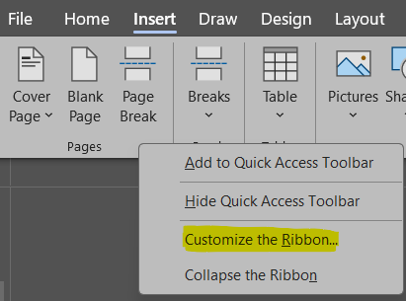
On the left side of the dialog box, select the option Insert Page & Section Breaks:
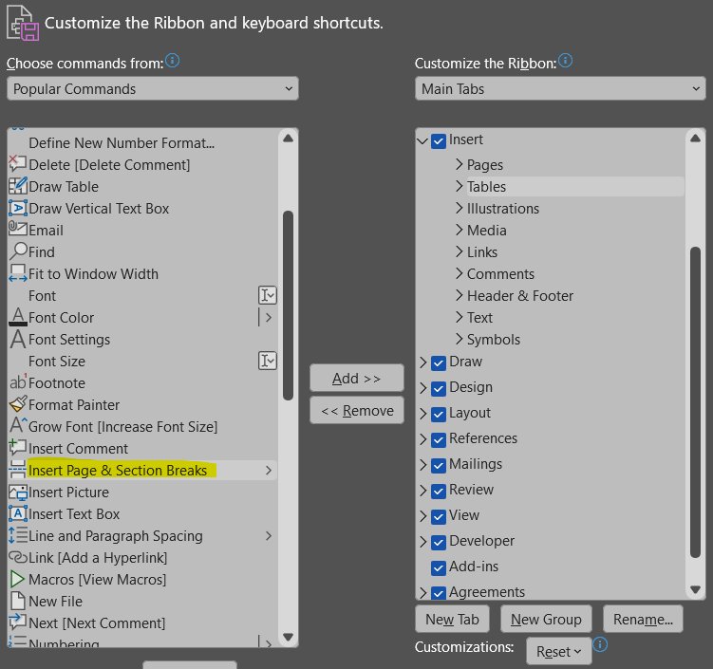
On the right side, select Pages and create a New Group (you may rename it as you wish; in this case, we called it Breaks). Then click Add:
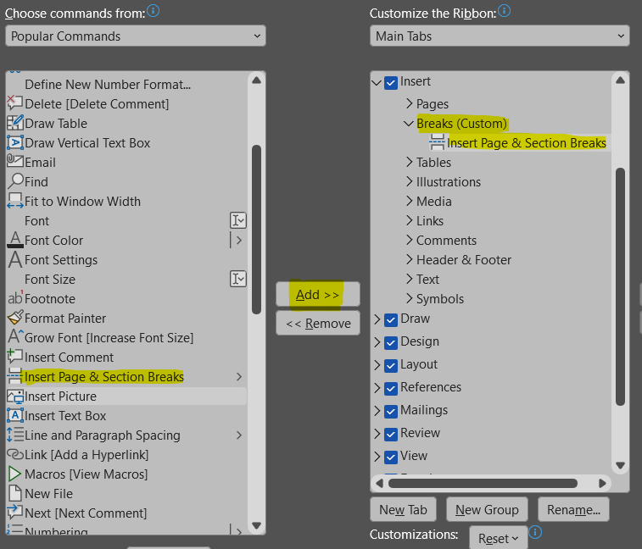
On the Insert Tab, you will find the new ribbon Breaks. Select the option Continuous to create a section break without adding a new blank page:
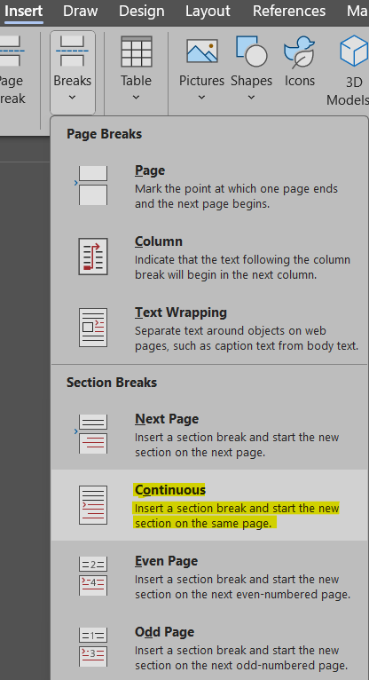
To insert the pagination, select the option Page Number, and choose Format Page Numbers:
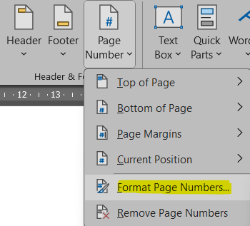

Select the Number format (i, ii, iii, … for the preliminary pages and 1, 2, 3, … for the body of the text):
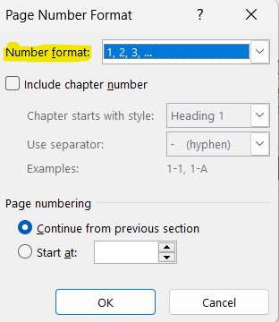

- Labels of figures and tables
To insert a figure label, go to the References tab and select the option Insert Caption:
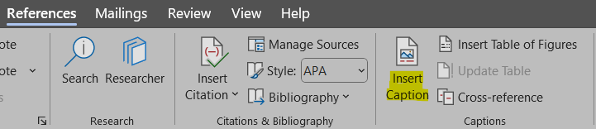
Select the option Numbering:
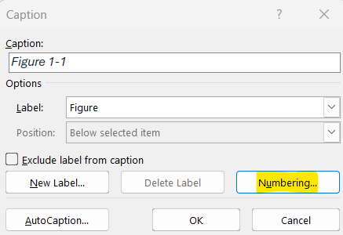
Choose Format 1, 2, 3, ... and select the box in the option Include chapter number (it is possible to select the Heading of each chapter and select a hyphen or a dot as separator between numbers):
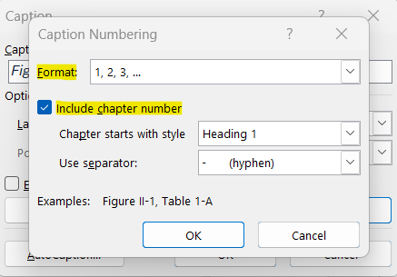

To insert a table label, go to the References tab and select the option Insert Caption:
In Label, select the option Table, then select Numbering:
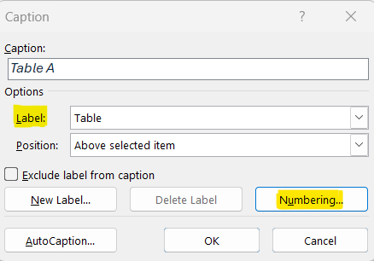
Choose Format 1, 2, 3, ... and select the box in the option Include chapter number (it is possible to select the Heading of each chapter and select a hyphen or a dot as separator between numbers):
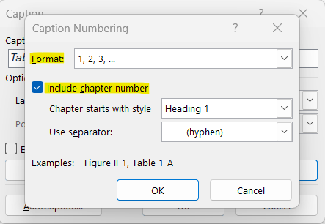

Here is an example of a figure label:

Figure 0.1 – Illustrative figure
Note that figure labels should be included after the figure. The alignment of the label should also be centered, instead of aligned to the left. Make sure the figure’s alignment is also centered, for a more cohesive layout throughout the work.
Here you can find an example of a table label:

Table 0.1 – Illustrative table
Title | Title
Text | Number
Text | Number
Text | Number

The student can freely choose the table design, as long as it remains consistent throughout the document. Note that table labels should always be included before the table. The alignment of both the table and the label should be centered throughout the work.
- List of Figures and List of Tables
To insert List of Figures, go the References tab and select the option Insert Table of Figures:
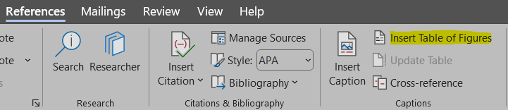
Verify that the Caption label selected is Figure:
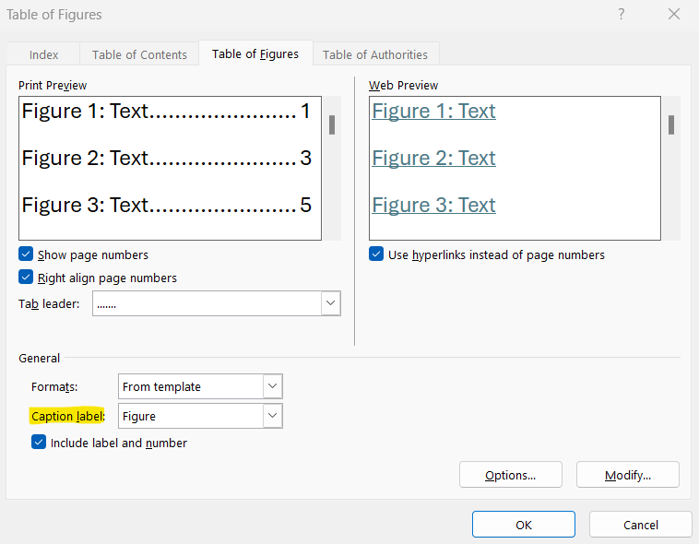

To insert List of Tables, go to the References tab and select the option Insert Table of Figures:

Verify that the Caption label selected is Table:
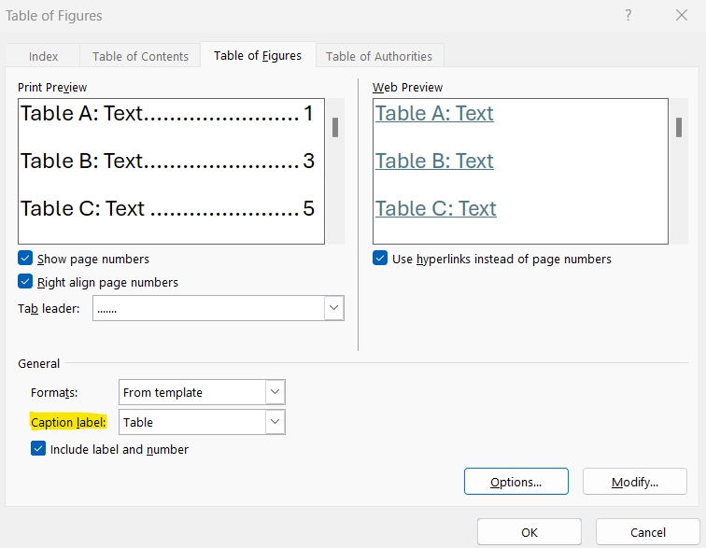
- Equations
We advise the identification of the equations present throughout the work to be done on the right:
${\left(x+a\right)}^{n}=\sum_{k=0}^{n}{\left({n \atop k}\right)x^{k}a^{n-k}}$ (0.1)

You can follow the chapter numeration, just like the figures and tables, or you can start with (1).
- Computer coding/Algorithms
For computing code, algorithms or other, it should appear with the label before the code framing, as the following example.
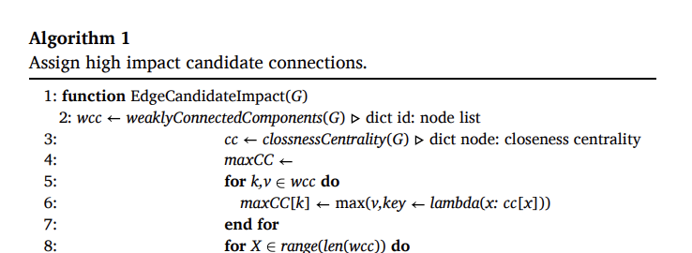
- Bibliographical references
Use APA Style for the entire document. Don’t forget to organize your bibliographical references alphabetically.
We suggest that students use a reference manager system (Zotero, Mendeley, EndNote).
Please review the APA style guide at: https://apastyle.apa.org/style-grammar-guidelines/references/examples
Example:
Author, A. A., Author, B. B., & Author, C. C. (Year). Title of article. Title of Periodical, volume number (issue number), pages. DOI or permanent link.

Here’s a references list with examples of different types of materials:

Areed, S., Alqaryouti, O., Siyam, B., & Shaalan, K. (2020). Aspect-Based Sentiment Analysis for Arabic Government Reviews. In Abd Elaziz, M., Al-qaness, M., Ewees, A., Dahou, A. (Eds.), Recent Advances in NLP: The Case of Arabic Language. Studies in Computational Intelligence (vol. 874, pp. 143–162). Springer. https://doi.org/10.1007/978-3-030-34614-0_8 [book chapter example]

Cook, J. (2024, June 21). Data To Decisions With ChatGPT: 5 Prompts To Analyze Business Metrics. Forbes. https://www.forbes.com/sites/jodiecook/2024/06/21/data-to-decisions-with-chatgpt-5-prompts-to-analyze-business-metrics/ [Website example]

Ercan, Ö., & Kabakçı, A. C. (2019). Subliminal Advertising Applications in Sport: Neuromarketing. International Journal of Sport Culture and Science, 7(1), 41-50. https://dergipark.org.tr/en/pub/intjscs/issue/45916/582724#article_cite [article example]

Krishen, A. S., Dwivedi, Y. K., Bindu, N., & Kumar, K. S. (2021). A broad overview of interactive digital marketing: A bibliometric network analysis. Journal of Business Research, 131, 183–195. https://doi.org/10.1016/j.jbusres.2021.03.061 [article example]

Milakovich, M. E. (2021). Digital Governance: Applying Advanced Technologies to Improve Public Service (2nd ed.). Routledge. https://doi.org/10.4324/9781003215875 [Book example]

Neves, J. P. P. C. (2021). Energy-efficient heating appliance behavior change: The role of green self-identity [Master's thesis, NOVA Information Management School]. RUN Repositório Universidade Nova. http://hdl.handle.net/10362/116182 [Master Thesis example]
Neves, M. F. S. T. (2024). Open Data as a Catalyst for the Evolution of Smart Cities [Doctoral dissertation, NOVA Information Management School]. RUN Repositório Universidade Nova. http://hdl.handle.net/10362/169801 [Doctoral Thesis example]

Redmon, J., Divvala, S., Girshick, R., & Farhadi, A. (2016). You only look once: Unified, real- time object detection. 2016 IEEE Conference on Computer Vision and Pattern Recognition (CVPR), 779–788. https://doi.org/10.1109/CVPR.2016.91 [Conference proceedings example]

- Appendixes’ Figures and Tables labels
To insert Figure and Table labels, start by inserting a Continuous Section Break in the previous page, on the Insert tab:
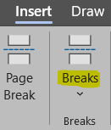
To insert a figure or table label, go to the References tab and select the option Insert Caption:
Select the option New Label:
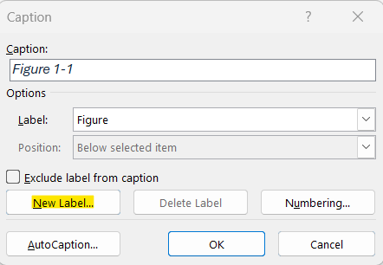

Create the new label with the indication of the Annex to which it belongs to – Figure A., Figure B., … or Table A., Table B, ...:
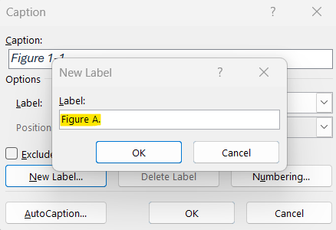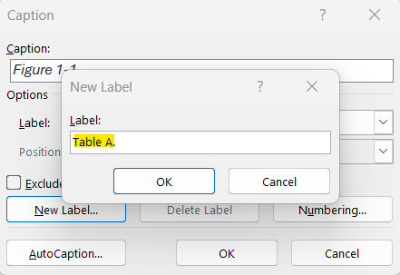

Introduction
This project presents a comprehensive analysis of the transformative role of artificial intelligence (AI) in forecasting and preventing sports injuries, projecting player performance, and supporting objective athlete evaluation. It explores the integration of Agentic AI for intelligent automation, Generative AI for narrative reporting, and blockchain for secure athlete record-keeping. The central aim is to harness these technologies to produce accurate, data-driven insights in controlled, practical conditions, leveraging historical datasets as the foundation for predictions.

Predicting injury risk in sports is a well-established goal in modern sports medicine, as it is critical for preventing injuries, optimizing athletic performance, and improving recovery strategies (Edouard et al., 2024). By accurately anticipating injury risks, teams can design individualized training and rehabilitation programs that help athletes avoid injury and recover more efficiently when injuries do occur (Vincent et al., 2022). This shift from reactive treatment to proactive prevention marks a significant advancement in sports health management (Fagher et al., 2020).

However, traditional prediction methods face persistent challenges, including variability between athletes, biological differences, and the complexity of modeling multiple interacting risk factors (Mausehund & Krosshaug, 2024). Data-related issues – such as inconsistencies in reporting, limitations in availability, and quality concerns – further complicate prediction accuracy (Nassis et al., 2023). The constantly changing nature of an athlete’s physiological state compounds these difficulties, as conventional models often lack the ability to capture real-time dynamics (Rossi et al., 2018).

AI-driven approaches address these shortcomings by integrating diverse data sources, including wearable sensor outputs, biomechanical assessments, performance metrics, and psychological indicators, to construct individualized athlete profiles (Topol, 2019). Beyond enhancing prediction accuracy, AI systems can deliver real-time monitoring and feedback, continuously tracking athlete condition during training or competition, and alerting coaches or medical staff to potential risks before they escalate (Rossi et al., 2018).

In elite-level sports such as the NFL, vast amounts of performance, workload, and injury history data are collected. Yet, much of this information remains underutilized in predictive decision-making processes (Wolf, 2016). This project focuses particularly on defensive backs (cornerbacks and safeties) and skill position players (wide receivers, running backs, and tight ends). These athletes are regularly exposed to high-speed, non-contact stresses, making them more susceptible to injuries such as ACL tears and hamstring strains. Despite this elevated risk, there are few widely accessible systems capable of translating week-to-week performance data into early-warning injury alerts or objective fatigue scores (Gabbett et al., 2014; Ribeiro et al., 2022).

At lower competition levels, analytics resources are even scarcer. Many teams operate without a dedicated analytics department or routine player monitoring processes. Yet, evidence shows that data analytics can enhance performance and support more informed decision-making (Koprinska et al., 2024; Moldstad, 2023). This project addresses this gap by proposing a system that can be seamlessly integrated into a team’s existing workflow, even in resource-constrained environments, without disrupting daily schedules. The goal is not to replace human expertise but to complement it, embedding analysis into everyday operations to support training, player health, and game preparation.

The proposed framework uses Agentic AI to automate the detection of patterns in health and performance data, retrieving relevant historical information for analysis. Generative AI then translates these findings into accessible, natural-language reports for coaches, analysts, and medical staff. Blockchain technology ensures data transparency, integrity, and traceability (Singh & Verma, 2024), enabling the creation of a universal digital Athlete Passport that securely stores player attributes, historical performance, and medical records.

Unlike existing platforms, this approach combines three main data sources:

- Historical player statistics – yearly data on performance and career development.
- Weekly performance data – focusing on the 2020 NFL season, capturing variables such as playing surface, consecutive game weeks, and weather conditions.
- Daily biometric monitoring – a full year of data from a former NFL player, including heart rate, sleep patterns, fatigue, and subjective condition ratings.

These datasets support predictive modeling for load management, injury prevention, and performance optimization. By cross-referencing official NFL metrics - such as PPR (Points Per Reception) fantasy points, which serve as a standardized measure of weekly player impact - this system offers a quantitative baseline for both player-to-player comparisons and overall team performance evaluation.

The analytical process runs continuously in the background, ingesting new data daily or weekly, storing it for longitudinal analysis, and calculating key performance indices. AI-generated outputs are delivered via a centralized web platform, providing staff with reports, visualizations, and automated alerts. Tailored prompt engineering ensures that Generative AI outputs are both accurate and contextually relevant, allowing non-technical stakeholders to interpret findings with ease.

Current sports analytics tools rarely combine structured athletic performance data with multi-source biometric inputs while leveraging low-code AI automation and no-code user interfaces for broad accessibility (Wolf, 2016). This project seeks to bridge that gap by delivering a scalable, practical solution for organizations without significant AI expertise or infrastructure.
With this, it is hoped that this study will contribute to the state of the art, adding value for further scientific investigations on related topics.

This project, hopefully, will prove how integration of Agentic AI, Generative AI, and blockchain-based athlete records can improve the efficiency, accuracy, and accessibility of injury forecasting, performance projection, and player evaluation in professional and semi-professional sports.

Literature review

Level 2 title
Sample text Sample text Sample text Sample text Sample text Sample text Sample text Sample text Sample text Sample text Sample text Sample text Sample text Sample text.

Level 3 title
Example of an unnumbered list:
- Item 1
- Item 2
- Item 3

Level 4 title
Example of a numbered list:
- Item 1
- Item 2
- Item 3

3. Methodology
Text about methodology Text about methodology Text about methodology Text about methodology Text about methodology Text about methodology Text about methodology Text about methodology Text about methodology Text about methodology Text about methodology Text about methodology Text about methodology Text about methodology Text about methodology Text about methodology Text about methodology Text about methodology Text about methodology Text about methodology

4. Empirical Study
Empirical study text Empirical study text Empirical study text Empirical study text Empirical study text Empirical study text Empirical study text Empirical study text Empirical study text Empirical study text Empirical study text Empirical study text Empirical study text Empirical study text Empirical study text Empirical study text Empirical study text Empirical study text Empirical study text

5. Results and Discussion
Text about results and discussion Text about results and discussion Text about results and discussion Text about results and discussion Text about results and discussion Text about results and discussion Text about results and discussion Text about results and discussion Text about results and discussion Text about results and discussion Text about results and discussion Text about results and discussion Text about results and discussion Text about results and discussion.

6. Conclusions and Future Research
Conclusion text Conclusion text Conclusion text Conclusion text Conclusion text Conclusion text Conclusion text Conclusion text Conclusion text Conclusion text Conclusion text Conclusion text Conclusion text Conclusion text Conclusion text Conclusion text Conclusion text Conclusion text.

Bibliographical References [This title should not be numbered]
Use APA Style for the entire document. Don’t forget to organize your bibliographical references alphabetically.
We suggest that students use a reference manager system (Zotero, Mendeley, EndNote).
Please review the APA style guide at: https://apastyle.apa.org/style-grammar-guidelines/references/examples
Example:
Author, A. A., Author, B. B., & Author, C. C. (Year). Title of article. Title of Periodical, volume number (issue number), pages. DOI or permanent link.

Appendix A (optional, appendixes should have letters instead of numbers)
[Appendixes are for materials, tables, or more explanation material only done by the student]
[It is mandatory to include in the appendixes the Ethics Committee Report when the research “[… involves human participants and personal data, regardless of whether it is collected online or in person, whether it is based on a survey, an experiment, a dataset, or interviews (i.e., it is also compulsory for observational studies and field interviews with managers)]”. You must get your report by answering a short questionnaire available here: https://novaims.eu.qualtrics.com/jfe/form/SV_eG085IyOwAj6a57

Annex A (optional)
[Annexes are optional, since they have material and sources not developed by the students, so in most cases referencing them is enough]


